410c receives data from qca4020  
  
0. Preface  
The QCA4020 monitors the status of the smoke sensor. When the monitored value is greater than a certain threshold, the level value of gpio is set to indicate that an event has occurred. For specific implementation, please see QCA4020 Smoke Sensor Data Read.docx  
  
1. Purpose  
This article aims to achieve:  
(1) The 410c development board monitors the state change of the gpio port to which the QCA4020 is connected, thereby generating an interruption.  
(2) Provide a node for the upper layer to view the status of the smoke sensor. One of them indicates that an event has occurred. You can set the node value to 0 by writing to this node.  
  
2. Connection diagram

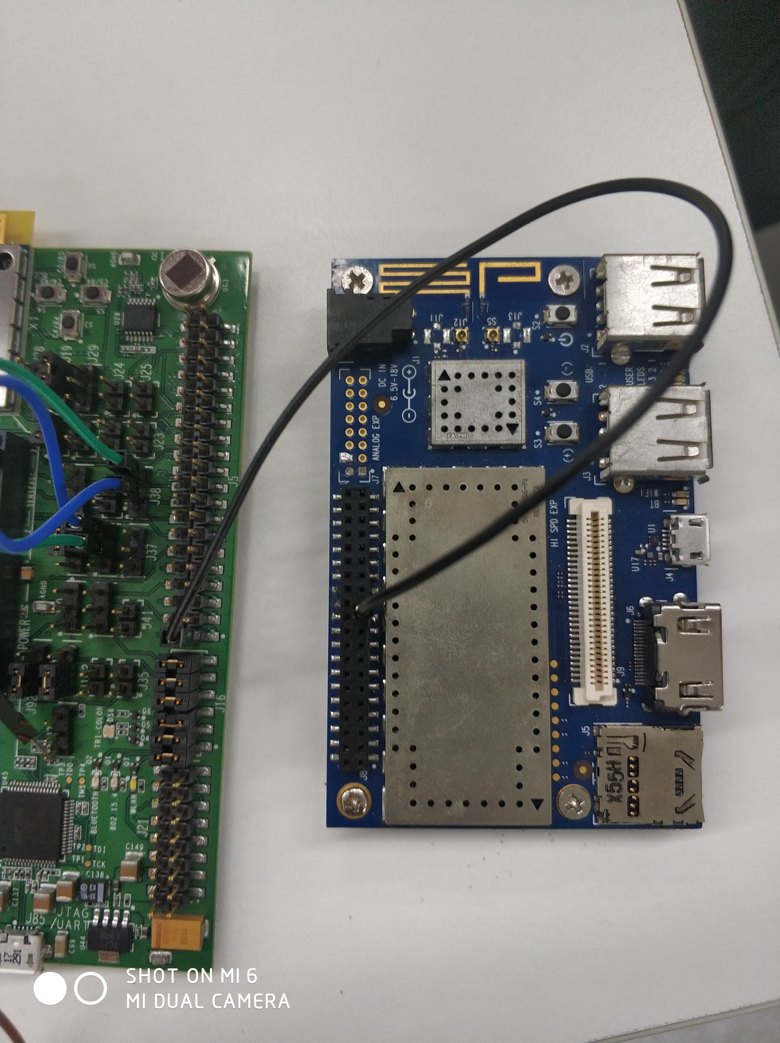

3. Code  
(1) Configure the device tree  
Add node

/*arch/arm64/boot/dts/qcom/apq8016-sbc.dtsi*/

qca4020 {

           compatible = "linux,QCA4020";

           interrupt-parent = <&msmgpio>;

           interrupts = <0 36 2>;

           gpio_int = <&msmgpio 36 0>;

};

（2）Configuring Makefile

/*drivers/misc/Makefile*/

obj-y += qca4020.o

（3）Drive implementation

#include <linux/module.h>

#include <linux/kernel.h>

#include <linux/init.h>

#include <linux/sysfs.h>

#include <linux/delay.h>

#include <linux/platform_device.h>

#include <linux/err.h>

#include <linux/device.h>

#include <linux/interrupt.h>

#include <linux/irq.h>

#include <linux/of_gpio.h>

#include <asm/uaccess.h>

#include <linux/kdev_t.h>

#include <linux/slab.h>

#include <linux/workqueue.h>

struct qca4020_data {

   struct platform_device *pdev;

   int flag;

   int gpio_int;

   int irq;

};

static struct qca4020_data* data;

static irqreturn_t qca4020_interrupt_handler(int irq, void *ptr)

{

   data->flag = 1;

   return IRQ_HANDLED;

}

static ssize_t qca4020_value_store(struct device *dev, struct device_attribute* attr,

                                           const char *buf, size_t len)

{

   data->flag = 0;

   return len;

}

static ssize_t qca4020_value_show(struct device *dev, struct device_attribute* attr,

                                           char *buf)

{

   ssize_t ret = sprintf(buf, "%d\n", data->flag);

   return ret;

}

static DEVICE_ATTR(value, 0664, qca4020_value_show, qca4020_value_store);

static int QCA4020_probe(struct platform_device *pdev)

{

   int result;

   struct device_node* node = pdev->dev.of_node;

   printk("qca4020 probe enter\n");

   data = devm_kzalloc(&pdev->dev, sizeof(struct qca4020_data), GFP_KERNEL);

   if (!data) {

       pr_err("%s kzalloc error\n", __FUNCTION__);

       return -ENOMEM;

  }

   dev_set_drvdata(&pdev->dev, data);

   data->gpio_int = of_get_named_gpio(node, "gpio_int", 0);

   if (!gpio_is_valid(data->gpio_int)) {

       pr_err("gpio_int not specified\n");

       goto err;

  } else {

       result = gpio_request(data->gpio_int, "qca_gpio");

       if (result < 0) {

           pr_err("Unable to request qca_gpio\n");

           goto err;

      } else {

           gpio_direction_input(data->gpio_int);

      }

  }

   data->irq = gpio_to_irq(data->gpio_int);

   result = request_irq(data->irq, qca4020_interrupt_handler,

                                                IRQF_TRIGGER_RISING | IRQF_TRIGGER_FALLING, "qca4020_intr", data);

   if (result < 0) {

       pr_err("Unable to request irq\n");

       goto err;

  }

   result = sysfs_create_file(&pdev->dev.kobj, &dev_attr_value.attr);

   if (result < 0) {

       printk("sysfs create file failed\n");

       goto err;

  }

   printk(KERN_INFO "QCA4020 probe success\n");

   return 0;

   err:

   kfree(data);

   printk(KERN_ERR "QCA4020 probe failed\n");

   return -EINVAL;

}

static int QCA4020_remove(struct platform_device *pdev)

{

       gpio_free(data->gpio_int);

       kfree(data);

       return 0;

}

static struct of_device_id mach_match_table[] = {

  { .compatible = "linux,QCA4020"},

  { },

};

static struct platform_driver QCA4020_driver = {

  .probe = QCA4020_probe,

  .remove = QCA4020_remove,

  .driver = {

      .owner = THIS_MODULE,

      .name = "QCA4020GPIO",

      .of_match_table = mach_match_table,

  },

};

module_platform_driver(QCA4020_driver);

MODULE_AUTHOR("yanggh0703@thundersoft.com");

MODULE_LICENSE("GPL");